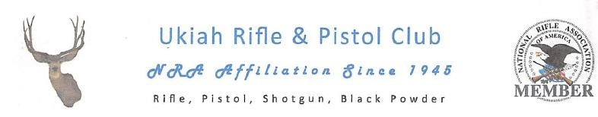

2018 URPC APPLICATION
#____________ _________________________________________________________________
Membership Sponsor Number (print clearly) Sponsor Signature (sign)

Applicant Name:______________________________/_______/____________________________________
FIRST M.I. LAST
Address:_________________________________________________________________________________
Mailing Address City State Zip
Home Phone:_________________________________Work/Cell Phone:______________________________

Date of Birth:_______/________/______________Email:_________________________________________

Please include a photo copy of your NRA card or the mailing address label from the most recent NRA magazine publication you receive.
PHOTO COPY OF NRA MEMBERSHIP IS REQUIRED WITH ALL APPLICATIONS
NRA Expiration Date:______/____/________

●Ukiah Rifle and Pistol Club Membership year is from July 1st thru June 30th (Fiscal)●

$
225.00

Includes
onetime

$25.00 Processing Fee

Make Check or Money Order payable to:

UKIAH RIFLE AND PISTOL CLUB
Mail payment, completed form, photo copy of NRA Membership to:
UKIAH RIFLE AND PISTOL CLUB
P.O. Box 2301
Ukiah, CA 95482
The Ukiah Rifle and Pistol Club membership is contingent on your valid NRA membership and signature of Waiver. Providing proof of NRA membership is an on-going requirement. We ask that you provide an email address to keep club publication costs low. URPC is a non-profit public benefit corporation. As a result, under California law, upon a proper request being made by a member of URPC, it could be required to release the names, address, and email addresses of its members to that member.

_________________________________________ _______________
Member Signature Date

1/22/2017 URPC

