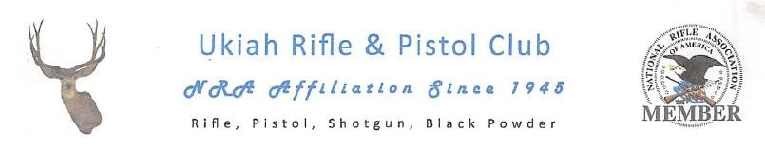

2018 RENEWAL

#________
______
____

URPC
Membership Number

Member Name:___________________________/_______/___________________________________
(print clearly) FIRST M.I. LAST
Address:____________________________________________________________________________
Mailing Address City State Zip
Home Phone:_________________________________Work/Cell Phone:_________________________

Date of Birth:_______/________/______________Email:_____________________________________

PROOF OF NRA MEMBERSHIP IS REQUIRED WITH ALL APPLICATIONS
Please include a photo copy of your NRA card or the mailing address label from the most recent NRA magazine received
NRA EXPIRATION:_________________
●Ukiah Rifle and Pistol Club Membership year is from July 1st thru June 30th (Fiscal)●

$200.00

Due date: June 15th, 2018

(Any renewals received after the due date, will be assessed a $25.00 processing fee)
Make Check or Money Order payable to:
UKIAH RIFLE AND PISTOL CLUB

Mail payment, completed form, photo copy of NRA Membership to:
UKIAH RIFLE AND PISTOL CLUB
P.O. Box 2301
Ukiah, CA 95482

The Ukiah Rifle and Pistol Club membership is contingent on your valid NRA membership. Providing proof of NRA membership is an on-going requirement. We ask that you provide an email address to keep club publication costs low. URPC is a non-profit public benefit corporation. As a result, under California law, upon a proper request being made by a member of URPC, it could be required to release the names, address, and email addresses of its members to that member.

_________________________________________ ________________________
Member Signature Date

05/01/2018 URPC

